Contact: Diane Elliot, Development Specialist  Hope’s Promise  Phone - 303.660.0277  Fax 303-660-0297  diane@hopespromise.com | 309 Jerry St. #202  Castle Rock, CO 80104  526 words

Press Release

Hope’s Promise Wins Best Annual Report Contest

Counsel & Capital presents $50,000 check to local adoption and global orphan care nonprofit, Hope’s Promise
Castle Rock, Colorado, January 8, 2018: Local adoption and global orphan care agency, Hope’s Promise, is awarded $50,000 winning the Best Annual Report Contest sponsored by a Colorado Springs consulting firm, Counsel & Capital. Diane Elliot, Development Specialist, said, “The Hope’s Promise creative team wanted to present our annual report in a creative and interesting way, and it worked. From the expressive family photo on the front cover, all the way through to the sweet face of one of our adopted children on the back cover, Counsel & Capital loved the photos, transparency, and honesty.”
Hope’s Promise has served Colorado from Castle Rock for nearly three decades. Hope’s Promise has one focus. As Beth Woods, the Executive Director of Hope’s Promise says, “We work hard, every day, to place orphaned and vulnerable children into loving homes through our international and domestic adoption, and global orphan care programs. We are all about creating permanence and finding a family for every child in need.”
Women who become pregnant unintentionally have many difficult choices to make. Hope’s Promise social workers surround the expectant parents with support and wisdom to help them determine what will work best for their future. Although more than 100 expectant parents were counseled in 2017, this service to our community often goes unnoticed.
In 2017 Hope’s Promise facilitated placing 27 children into loving adoptive families. Licensed by the Colorado Department of Human Services and Hague-accredited by the Council on Accreditation, Hope’s Promise is a reputable adoption agency providing outstanding service and support to birth parents, adoptive parents and helping to educate our community partners about adoption.

Global orphan care is an enormous ongoing concern. Less than 1% of all orphaned children will ever be adopted. Hope’s Promise has responded by creating a holistic global orphan care program, providing permanent families to children who are abandoned or unable to be cared for by parents or extended family. Currently serving in Kenya, Nepal, Vietnam, and Zimbabwe, Hope’s Promise works with indigenous staff to bring children into loving family home environments. Through sponsor partners in the United States, Hope’s Promise provides orphaned and vulnerable children with a family, home, food, clothing, and an education.
The Best Annual Report Contest is sponsored by Counsel & Capital, a company whose mission is to build bridges of trust and accountability between evangelical Christian ministries and donors. The contest was created to challenge nonprofits to provide quality information to current and potential donors. Founder, Randon Samelson shares his wisdom in a powerful book called Break Through. Written with the nonprofit leader in mind, this book serves to help identify dreams and remove roadblocks to help those dreams become a reality.
A special thank you to Counsel & Capital for investing in nonprofits who are making a difference locally and globally. Beth Woods comments, “It is a wonderful privilege to walk together with like-minded community partners like Counsel & Capital, to accomplish the important work that we are called to do.”
For more information about the important work of providing a family for every child, contact Hope’s Promise through their website, www.hopespromise.com.
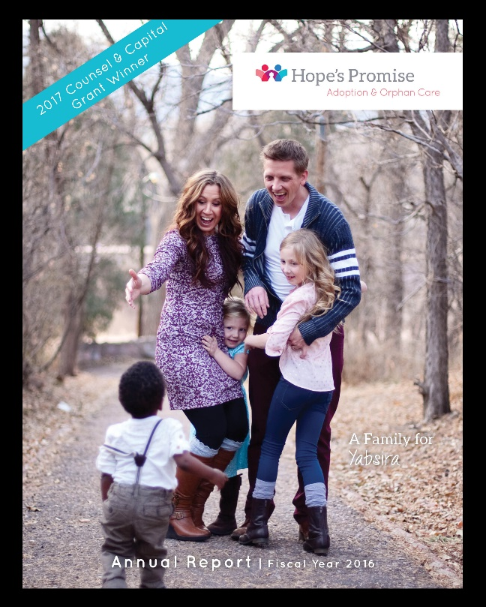
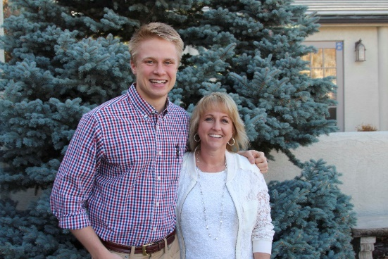

Parker Samelson, Counsel & Capital VP
and Beth Woods, Hope's Promise Executive Director

