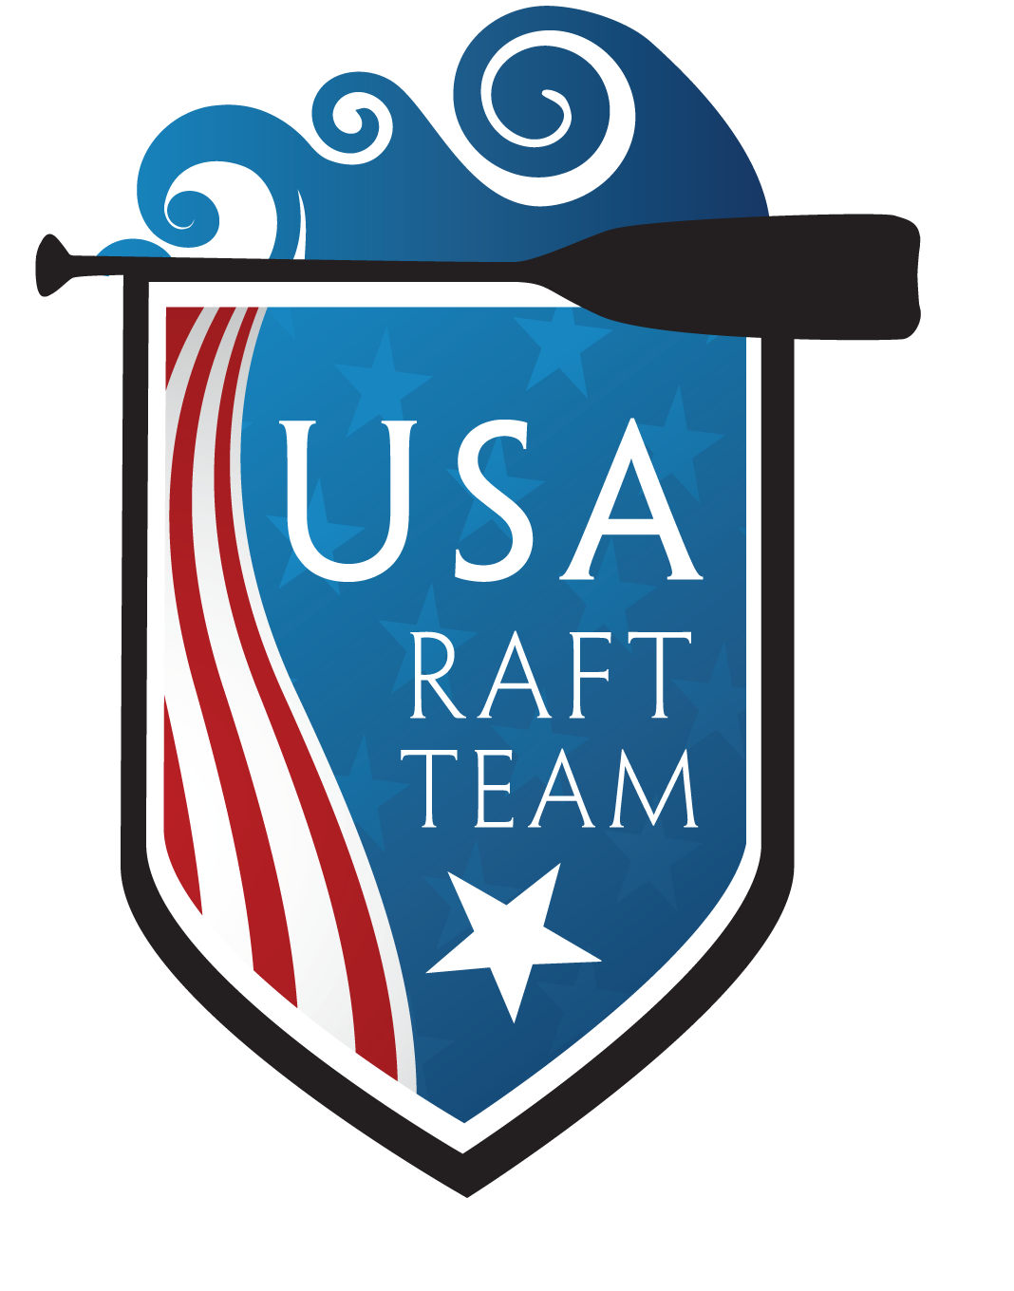
Contact Eva Lambert  Cell 970-281-2046  Email evangelineroselambert@gmail.com  Website www.raftracecolorado.com | FOR IMMEDIATE RELEASE  April 11, 2017

USA Women’s Raft Team going for gold

At the 2017 World Rafting Championships
Golden, Colorado, April 11, 2017– The USA Women’s Raft Team, also known as the Colorado Women’s Raft Team won the USA title and needs your help in their quest for bringing home the WORLD Women’s Rafting Title!
“We put a lot of hard work leading up to our race, we race fiercely and in the end, we celebrate with our river family.” Eva Lambert
Join The USA Women’s Raft Team to celebrate their win of the USA title and preparation for the World Championships! Team fundraisers include beer, music and Team USA swag. For more information visit: www.raftracecolorado.com.
Events for the public:
The USA Women’s Raft Team has partnered with Denver Greenway Foundations Organization to put on a rafting event (free to the public) during the South Platte River Festival. Details coming soon!
The USA Women’s Raft Team partnered with Eddyline Restaurant and created the Eddyline Restaurant Raffle. Enter for a chance to win two airfare tickets to watch the 2017 World Rafting Championships. Raffle tickets are $30 per ticket, 4 tickets for $100 and 10 tickets for $200. Value up to $3,000 for flights (direct and indirect) to Osaka International Airport (ITM). Name of traveling participants due by July 1st, 2017. Rules and restrictions apply. Proof of valid passport must be supplied at the time of notification of winning. To purchase tickets visit https://usaraftteams.rallyup.com/r6womens-usa-raft/2THJ2J.
Eddyline Restaurant Raffle social media plugs:
Facebook-
"The @Colorado Women’s Raft Team has teamed up with @Eddyline Restaurant to raffle off airfare tickets for TWO lucky winners to watch the 2017 @IRF World Rafting Championships in Japan! Raffle tickets are only $30. Purchase tickets link."

Twitter-
"@COWRaftTeam has teamed up with @eddylinepub!! Enter to win 2 flights to JAPAN for @Intraftred Rafting Championships in JAPAN! $30 to enter the raffle!​​Follow the link for more info."

Instagram-
“@coloradoraftracing has teamed up with @eddylinerestaurant for the chancefor you to win 2 flights to JAPAN! $30 to enter the raffle. Paste the link for more information https://usaraftteams.rallyup.com/r6womens-usa-raft/2THJ2J.”

"Kokatat is proud to sponsor the Colorado Women's Raft Team in all their passion and dedication toward a sport they work to be their best at." Kokatat.com
# # #
If you would like more information about these topics, please contact Eva Lambertat 970-281-2046 or email at evangelineroselambert@gmail.com.

