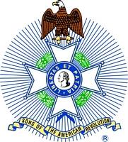
For Immediate Release:

Robert W. Haines
Secretary, Mount Evans Chapter
Colorado State Society
Sons of the American Revolution
303-526-3051
rwhdjh@aol.com

Sons of the American Revolution Featured at Sterling’s Heritage Festival

Sterling, CO, July 4, 2017 – Independence Day. On July 4th, the Overland Trail Museum in Sterling, Colorado featured the Sons of the American Revolution during its annual Heritage Festival.

Each year, the Overland Trail Museum holds its Heritage Festival on the 4th of July. While the museum is dedicated to educating the public about the Overland Trail, this year it decided to shift the festival’s focus to the founding of the country. “We are so happy that the Sons of the American Revolution joined us for the Heritage Festival this year,” said Kay Rich, Curator of the Overland Trail Museum. “They bring a rich amount of experience regarding the founding of the country that they are pleased to share with the community.”

Representing the Sons of the American Revolution in the annual event was the Mount Evans Chapter of the Colorado State Society. The Chapter, whose members are from the greater Denver Metro area, provided a Color Guard of members dressed in colonial uniforms who participated in the raising of the American flag at the start of the festivities. Later, the members discussed the founding of the country and the events leading up to the Revolutionary War in which we gained our independence from Great Britain. As part of the presentation, the contents of a “Patriot’s Chest” were displayed that included period clothing, toys, currency, hunting/military equipment, household items and documents such as the Declaration of Independence and the Constitution.

“As descendants of men who either fought in the Revolutionary War or supported it in some way, we are always pleased to describe to the public what life was like in those times and what led the citizens of that day to rebel against the English King,” explained Captain Bob Easterly (U.S.N.R., Ret.), President of the Mount Evans Chapter. “It was our pleasure to be invited to participate in this great event hosted by the Overland Trail Museum.”

Attending in colonial uniform in addition to Captain Bob Easterly of Castle Rock were Rick Neeley of Sedalia, Curt Ledall of Westminster and Walter Weart of Arvada.

The Sons of the American Revolution (SAR), the largest male lineage organization in the U.S., consists of 50 societies with more than 500 local chapters, several international societies and over 34,000 members. SAR is dedicated to assisting our members, schools, teachers and the general public in their efforts to sustain and preserve our history and constitutional principles.

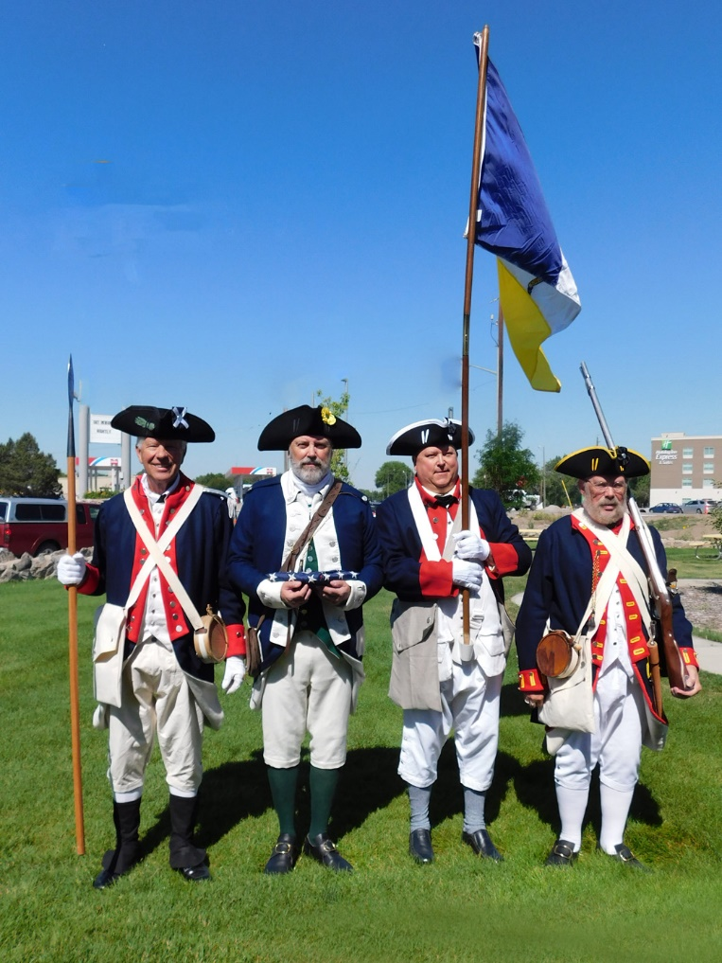
Left to Right: Captain Bob Easterly, Rick Neeley,
Curt Ledall and Wally Weart

