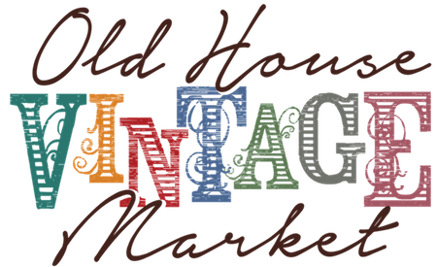
FOR IMMEDIATE RELEASE

Contact:
Bernadette Rankin
Founder, The Old House Vintage Market
oldhousevintagemarket@gmail.com

or

Jacquelyn Gutc
President, Magpie Media
Jacquelyn@magpie-media.com

The Old House Vintage Market Launches Mentor Program
Golden teen receives free market space, guidance as OHVM Young Creative

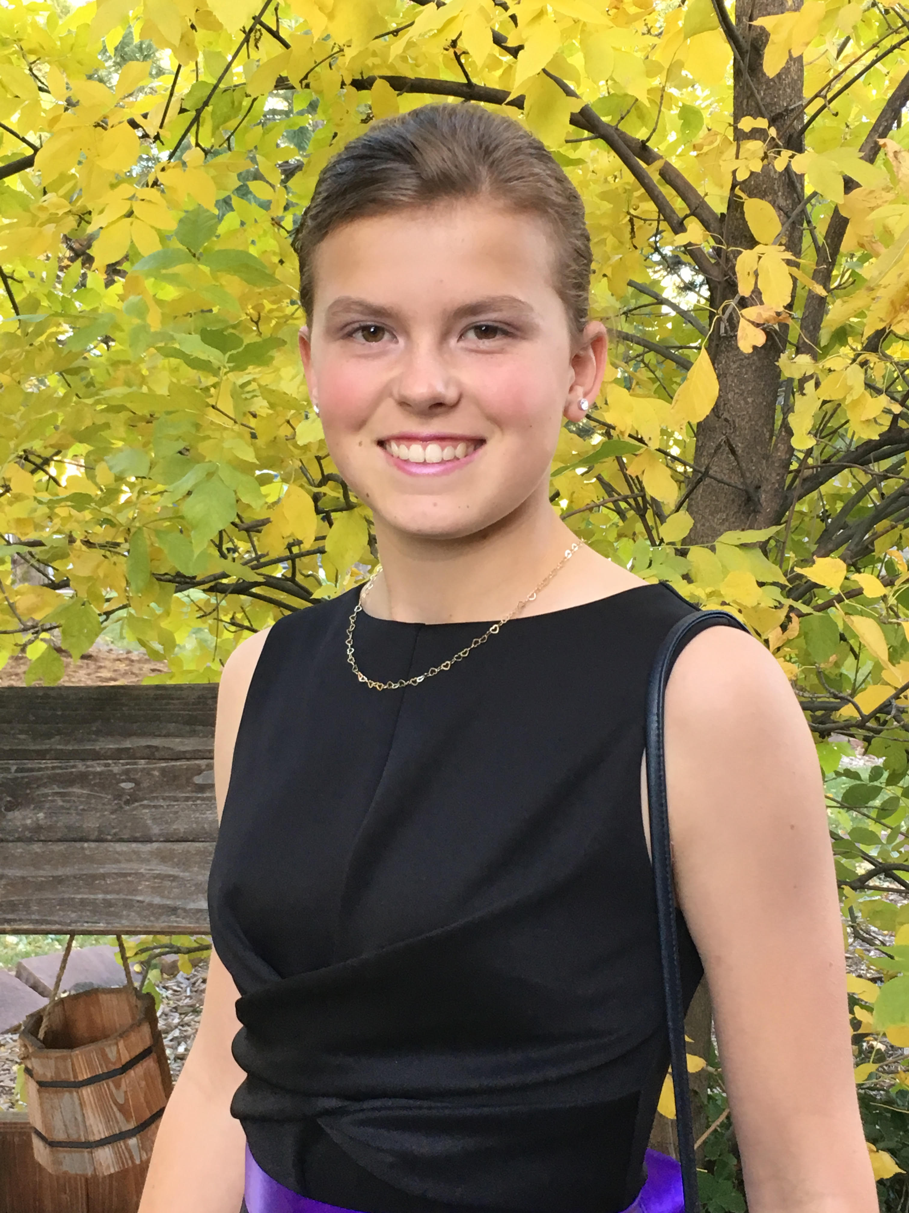
LOVELAND, Colo. — Oct. 19 — The Old House Vintage Market, an upscale antique, vintage, salvage, upcycled and handmade market, is thrilled to announce the launch of its In the Making Young Creatives program. The goal of the Young Creatives program is to help mentor youths who are interested in turning their ideas and love of creating into a successful business.
The first Young Creative is 14-year-old Kendall Custer of Golden. Kendall knits wearables such as hats, as well as corn bags and kitchen essentials.
As part of the Young Creatives program, Kendall was given a market space free of charge and will sell her items at the Holiday Old House Vintage Market, Nov. 10-11, at the McKee 4-H Building at The Ranch Events Complex in Loveland.
“Even as an adult, starting a business — and putting yourself out there as an artist — can be intimidating. It’s hard to know where to even start to make it successful, so to have that ambition as a teenager is really special,” said OHVM Founder Bernadette Rankin. “Our vendors have decades of success between them and are so encouraging of each other and newcomers, so we thought it would be a great opportunity to invite a Young Creative into the fold to help foster her growth as a creator and business owner.”
Kendall began knitting around the age of 8 when a family friend first got Kendall and her mother, Deanna, interested in loom knitting. The family friend eventually got Kendall her first loom knitting set for Christmas and she’s been doing it ever since, along with a variety of other crafting including sewing, scrapbooking, wood working, finger and needle knitting, and more.
Kendall and her parents are no strangers to craft shows and are regular shoppers at them. And ever since she started knitting, Kendall wanted to become a vendor.
“Kendall has wanted to participate in a craft show every year, but the booth space was too expensive for a young kid,” said her mother Deanna. “When Bernadette contacted us, Kendall was ecstatic.”
As the OHVM Young Creative, Kendall will get assistance in marketing, setting up a market/store front, display techniques, customer service, and the technical and financial side of selling.
Deanna said Kendall has prepared for the OHVM by researching what other vendors sell, how they price and how they set up booths when she visits other markets and is using that knowledge to prepare for her first time as a vendor. Kendall has learned how much time goes in to crafting enough items to have stock to sell and has already had success selling baby hats at her family’s garage sale.
“Kendall is hoping to learn how to calculate what goes into making the product and then price the product accordingly, then learn to turn a profit and use that to purchase more materials to make more product,” Deanna said. “She wants to be able to use some of her profit to purchase more supplies and wants to contribute the rest to our family vacation to Hawaii next year.”
The Holiday Old House Vintage Market will feature over 80 spaces for shoppers to find gifts for everyone on their list.
The Friday Night Shopping Party is an exclusive ticketed event, open 5-9 p.m. Friday, Nov. 10. Tickets are $16 and half of proceeds will benefit a charity helping Hurricane Harvey recovery efforts in Texas. The first 300 shoppers who purchase their tickets online in advance will receive an OHVM-branded tote, vouchers for free snacks and drinks, other goodies from vendors and — of course — first dibs on the merchandise. Friday tickets are also good for Saturday.
All-Day Shopping is 9 a.m. to 4 p.m. Saturday, Nov. 11. Tickets are $6 and available online and at the door. Children 12 and younger get in free both days.
The Holiday Old House Vintage Market will be at the McKee 4-H Building at The Ranch Events Complex in Loveland. Market updates are available on the Facebook page. More details are at OldHouseVintageMarket.com.
*Market photos available upon request.

About Old House Vintage Market
The Old House Vintage Market is an upscale antique, vintage, salvage, upcycled and handmade market. Launched in Golden, Colorado, in 2016, the market had been a dream of founder Bernadette Rankin’s since 2010. Her first market, with over 30 vendors and 700 attendees, was held in May 2016. By the third market in January 2017, The Old House Vintage Market grew to 85 vendor spaces with double the shoppers of the first. OHVM won Readers Choice for Best Festival in 5280 magazine’s annual Top of the Town awards in 2017 and was a Denver A-List finalist. OHVM will host its fifth market — its third in Loveland — Nov. 10-11, 2017, with more on the schedule for 2018. For more information, visit OldHouseVintageMarket.com.

