For Immediate Release:

Colorado Springs Fall RV Show & Sale
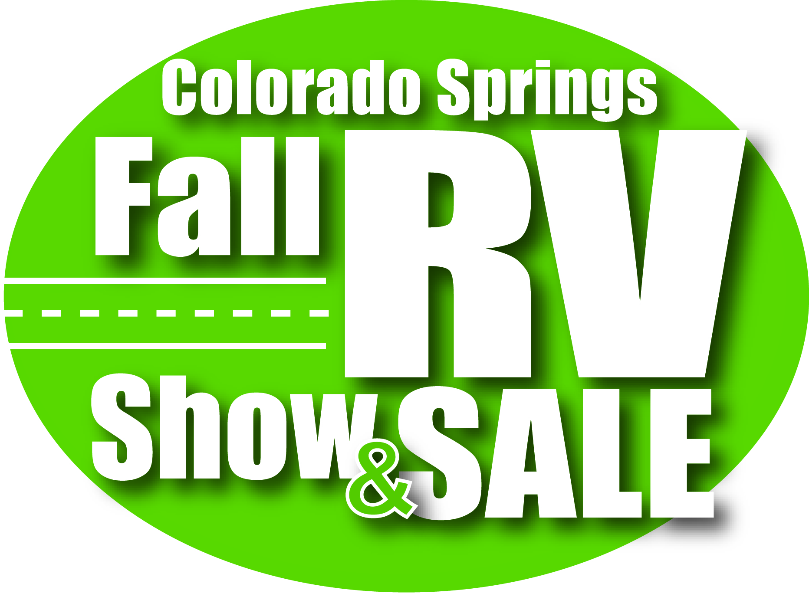
Snowbirds heading south can’t miss the END-OF-SEASON CLEARANCE DEALS at the Colorado Springs Fall RV Show & Sale FRIDAY & SATURDAY SEPTEMBER 8th-9th at the new Altered Reality Event Center, 3960 Palmer Park at Academy with FREE parking! With over 40,000 square feet of DEALS on Motorcoaches, fifth wheels, pull behinds and more this family friendly event will have it all under one roof! Get ready to hit the road whether it is a large motorhome or a small tent, and prepare yourselves for the great outdoors!
Find the perfect camper for your journey and shop from some of the top brands including Cirrus truck camper, Retro RV, Lance, Sportscoach Diesel Pusher, Gulf Stream Class C, Vengeance Toy Hauler, Alpine, Avalanche, Heritage, Glen, MPG, Sundance, Sunray and more!
Along with an array of camping and traveling exhibits, be sure to check out High Impact Archery’s ultra-safe Hover Ball target system, fun for all ages!

Show dates, times, and ticket prices are as follows:

Friday, September 8th – NOON to 7PM
Saturday, September 9th – 10AM to 6PM

Adults $6.00, Youth 16 and under free. FREE PARKING!

For more info contact: Show Manager, Tiphani Ruark at (816) 676-0483 or at tiphanir@rjpromotions.com or visit www.ColoradoSpringsRVShow.com

Sponsored in part by MCM Elegantè Suites.

