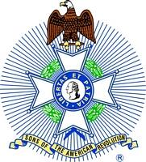
For Immediate Release:

Robert W. Haines
President, Mount Evans Chapter
Colorado State Society
Sons of the American Revolution
303-526-3051
rwhdjh@aol.com

District Attorney Peter A. Weir Receives Law Enforcement Commendation Medal at Mt. Evans, SAR Annual Meeting

Denver, CO, January 13, 2018 – Peter A. Weir, District Attorney for Gilpin and Jefferson Counties, spoke to the Mt. Evans Chapter of the Colorado Society of the Sons of the American Revolution at their Annual Meeting on Saturday, January 13, 2018 at the Park Hill Golf Club and received its annual Law Enforcement Commendation Medal.

On January 13, 2018, the Mt. Evans Chapter of the Colorado Society of the Sons of the American Revolution awarded Peter A. Weir, the District Attorney for Gilpin and Jefferson Counties, its annual Law Enforcement Commendation Medal. The medal is presented annually to an individual who has served with distinction and devotion in the field of law enforcement. The award may be made to peace officers, attorneys, judges, prosecutors or legislators.

The Mt. Evans Chapter recognized District Attorney for his long and distinguished career in law enforcement as an attorney, prosecutor, judge, governor appointee and now twice elected District Attorney for the counties of Gilpin and Jefferson. During his career, he has promoted and defended the principles of the Declaration of Independence, the Constitution and the Bill of Rights that are the core principles of the Sons of the American Revolution.

“We are especially pleased to present this year’s Law Enforcement Commendation Medal to Peter Weir in recognition of his long and faithful service to our community,” explained Captain Bob Easterly (U.S.N.R., Ret.), outgoing President of the Mt. Evans Chapter. ‘He epitomizes the dedication and accomplishment that this award was created to recognize.”

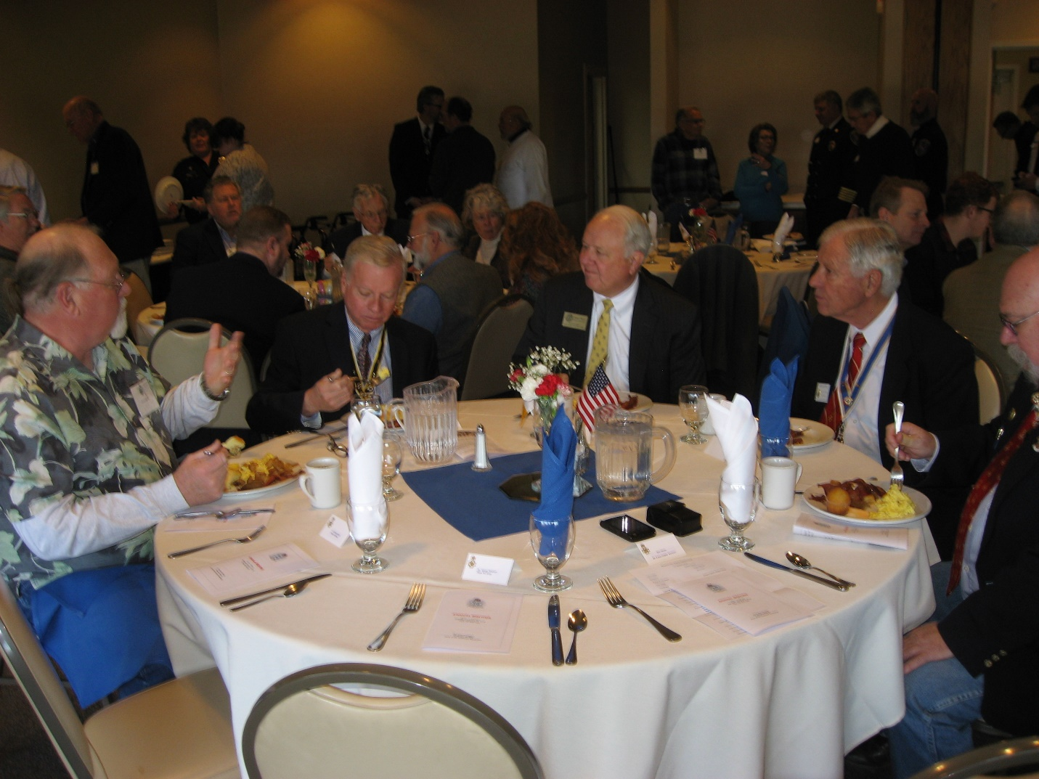
Left to Right: Steve DeBoer, Past COSSAR President; Wayne Snodgrass, SAR Vice President General; Peter A. Weir, District Attorney; Robert Easterly, President, Mt. Evans, SAR; and Gene Cheney, COSSAR President.

After receiving the award, District Weir spoke to the Mt. Evans Chapter members and their guests for approximately a half hour. During his speech, he described his activities as District Attorney and the efforts that his office is making in protecting the citizens of Gilpin and Jefferson Counties focusing on the issues of evil, courage and hope.

Also receiving awards at the Annual Meeting were Ms. Annie Dorchack of Evergreen Fire & Rescue, who was awarded the annual Life Saving Medal and Ms. Pati Stajar and Mr. Rod Cameron of the Foothills Fire Protection District, who were awarded the annual Fire Safety Commendation Medal. “The Mt. Evans Chapter is proud to recognize each year members of the fire safety and emergency medical communities for the live saving work they do each and every day,” Bob Haines, Incoming Chapter President explained. “We depend on these people so very much and they so often do not receive the recognition that they are due.”
The Mt. Evans Chapter represents those members of the Sons of the American Revolution living in the Denver Metro area. It is one of four Chapters in the Colorado Society. The Sons of the American Revolution (SAR), the largest male lineage organization in the U.S., consists of 50 societies with more than 500 local chapters, several international societies and over 34,000 members. SAR is dedicated to assisting our members, schools, teachers and the general public in their efforts to sustain and preserve our history and constitutional principles.

