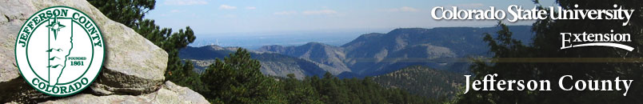
FOR IMMEDIATE RELEASE
March 21, 2017
Media Contact: Lisa Vernon

303.271.6620
lvernon@jeffco.us

WILDFLOWER TOURS FOR BEGINNERS

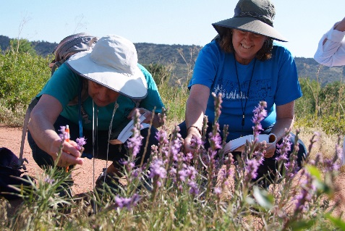
Curious about the many blooming plants popping up in local natural areas? Sign up for one of the Wildflowers of Green Mountain classes being offered through CSU Extension either May 14 or May 31 from 8:30 AM to 12:30 PM. These tours are easy walks designed for beginners who would like to learn fun facts and how to identify the wildflowers at this close in open space park. Register at https://npm.eventbrite.com.
Learn more about earning a Native Plant Master® certificate, volunteering and offerings in other locations at www.M2Mnativeplantmaster.org or call 303-271-6621. For detailed information on 1,000+ Colorado plants, see http://coloradoplants.jeffco.us. CSU Extension programs are available to all without discrimination.

About the Native Plant Master® Program
The Native Plant Master® program was developed by Colorado State University Extension to educate
the public about native plants in order to foster stewardship of native plants, sustainable landscaping and management of weeds that threaten native ecosystems. The program is designed to enable residents to use research-based information to address their needs related to sustainable landscaping and invasive weed management. Learn more at www.COnativeplantmaster.org or call 303.271.6620.

About Jefferson County Extension
Jefferson County CSU Extension empowers county citizens and enhances their quality of life through education, innovation and excellence in service. Youth and adult programs are available that include 4-H Youth Development, Family & Consumer Sciences, Native Plant Master, Nutrition Education and Yard and Garden Horticulture. For more information call 303.271.6620 or visit http://jeffcoextension.org. Extension programs are available to all without discrimination.

###

