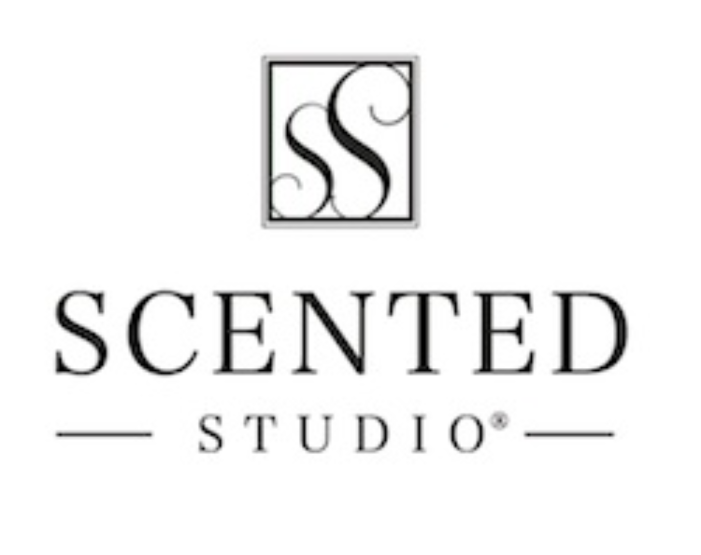
Scented Studio Press Release
Imagine the possibilities of being able to create your very own fragrance, naming it, and then placing into almost any product you want!

Englewood, May 20, 2017 -- After 5 years in Cherry Creek North, Scented Studio is moving to a brand new location where you can experience the journey of creating a scent that’s completely your own.

Grand Opening Event
Please join us May 20th, 2017 from 4:00PM to 9:00PM for the grand opening of our brand new location. We will be having an Open Bar, DJ, Appetizers, Deals, Raffle at 7:00PM, and Extra Perks for Showing Up!
Click Here to visit our event page.

“I have been going to Scented Studio for a while and their products are some of my favorites. The ingredients are all natural, moisturizing and hold fragrance very well. I am very particular about my skin care products as I have sensitive skin and get allergic reactions quite often. With their products my skin feels even healthier. Highly recommend!”
- Julia S., Frequent Customer

About Scented Studio
Our specialty is creating custom fragrances, and recreating discontinued scents. Our Brick & Mortar Store is home to over 500 Different Fragrant & Essential Oils that can then be blended into almost any product we carry. We are also home to the Scented Journey Perfume/Cologne Workshop. Visit www.scentedstudio.com for more information!

Press Contact
E-mail: info@scentedstudio.com
Phone: (303) 333-3315
Press Kit: www.scentedstudio.com/presskit
Location: 3437 S. Broadway Englewood, Colorado 80113

