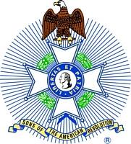
For Immediate Release:

Robert W. Haines
Secretary, Mount Evans Chapter
Colorado State Society
Sons of the American Revolution
303-526-3051
rwhdjh@aol.com

Mt. Evans SAR Makes a Presentation to Scout Pack 268

Denver, CO, January 2, 2018 – Robert Hampton of the Mt. Evans Chapter of the Colorado Society of the Sons of the American Revolution (SAR) described the events leading up to the Revolutionary War and life as a colonial family and as a Continental soldier to Scout Pack 268 at Homestead Elementary School on December 20, 2017.

Thirty scouts, ranging from Cub Scouts to Weblos, were enthralled by a recent presentation about the Revolutionary War and the life of the colonialists and Continental solders given by Robert Hampton, a member of the Mt. Evans Chapter of the Colorado Society of the SAR. Held in the Homestead Elementary School gymnasium on December 20, 2017, the Scout Master, Johannes von Alvensleben, and several parents of the scouts participated in the discussion. Compatriot Hampton was ably assisted by his ten year old grandson, Blake Hampton, who is in the Fifth Grade. Both Hamptons were dressed in uniforms of Colonial soldiers.

“It is always gratifying to share the principles and events that led up to the Revolutionary War and our country’s fight for independence,” explained Compatriot Hampton. SAR members call themselves “Compatriots” and have documented their lineage to someone who either served or otherwise supported the Patriots in the Revolutionary War. “It is particularly enjoyable to describe these events and what the people were fighting for to young people, such as the scouts,” Compatriot Hampton further elaborated. “They are so inquisitive about the past and always come up with the best questions,” he added.
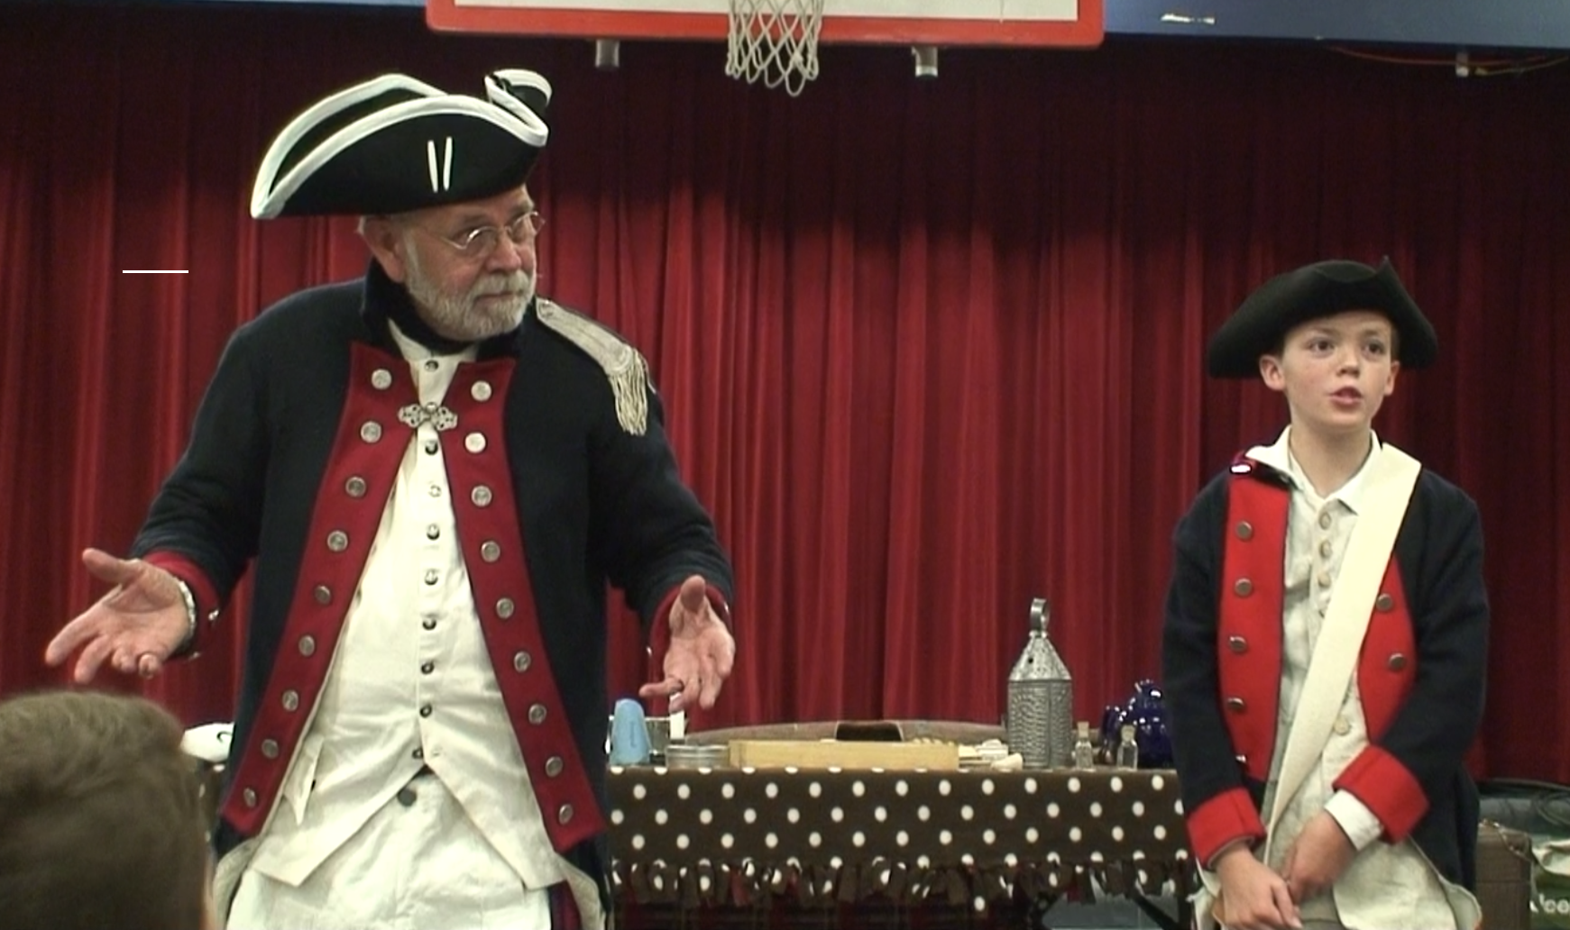

“The Mt. Evans Chapter makes several presentations a year concerning the Revolutionary War to scout packs, schools and other community groups,” related Captain Robert Easterly (U.S.N.R., Ret.), the President of the Mt. Evans Chapter. “We use what is called the ‘Patriot’s Chest’ that is a container that holds various items found during Colonial times. We have found that the audience being able to see and feel objects that our ancestors may have used adds to the authenticity of the presentations.”

Compatriot Hampton was joined in his presentation by his grandson, who was dressed as a Colonial soldier. He could have been a drummer or other young person that often joined their fathers in the fight for freedom. “It is something special to me to be able to share this experience with my grandson,” Compatriot Hampton said. “It means a lot to see him learn firsthand the foundational principles of this great country of ours.”

The Mt. Evans Chapter represents those members of the SAR living in the Denver Metro area and is one of four Chapters in the Colorado Society. The SAR, the largest male lineage organization in the U.S., consists of 50 such societies with more than 500 local chapters, several international societies and over 33,000 members. It is dedicated to assisting our members, schools, teachers and the general public in their efforts to sustain and preserve our history and constitutional principles.

