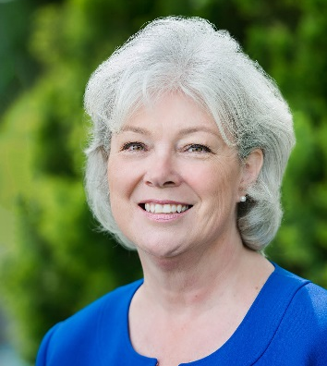
Carol Henry brings over 30 years of experience in private practice, focusing on park master planning and design, along with facilitating public processes. She has designed over 50 parks for 24 municipalities. These included new park sites and redevelopment and renewal planning, meeting the needs of growing communities and changing activities of park users. Carol’s extensive experience in managing large scale public projects for agencies in Washington and along the Front Range of Colorado has resulted in such award-winning sites as Meadow Crest Inclusive Playground in Renton, Washington; Bayou Gulch Regional Park in Douglas County; Sandstone Ranch Adventure Playground in Longmont; Hideaway Park in Winter Park; and Discovery Park in Wheat Ridge, Colorado. Additionally, Carol was the Principal for Lakewood’s recent Surfside Splash Park Renovations which received the Colorado Parks & Recreation Association’s Columbine Award for Renovated Facility Design.

