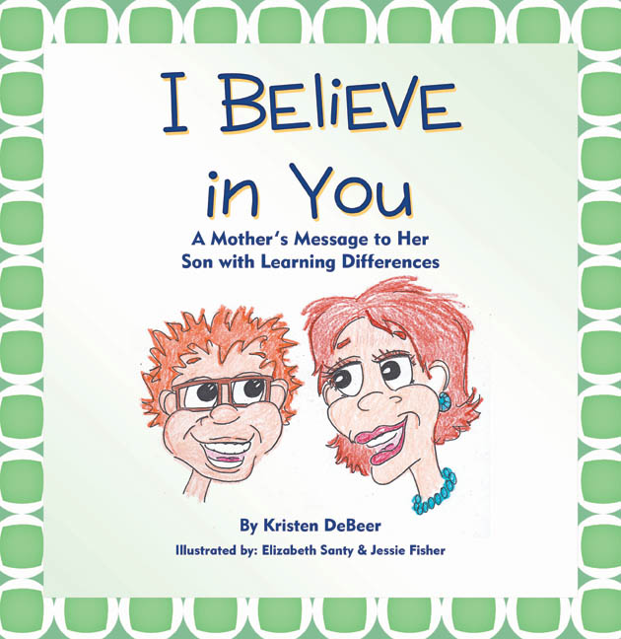
Kristen DeBeer
2901 Newbury Ct
Highlands Ranch, CO 80126
303-807-2243

www.ibelieveinyoubook.com
kristen.debeer@ibelieveinyoubook.com

Colorado Community Newspapers
Highlands Ranch Office
9137 S. Ridgeline Blvd. Suite 210
Highlands Ranch, CO 80129

March 11, 2013

To Whom it May Concern:

I am a parent and newly minted children’s book author from Highlands Ranch. I am writing to you in hopes that you might be interested in my story, which started when my oldest child began attending public school. Jack never fit the mold of a traditional learner, and has struggled to succeed according to the standards against which we measure children in grade school. He was diagnosed along the way with ADHD and SPD, and later, dyslexia, all of which contribute to his learning differences.

I wrote I Believe in You: A Mother’s Message to Her Son with Learning Differences for Jack, and for the thousands of other kids whose learning differences affect their self-esteem. The book offers a positive message to different learners and helps kids understand a little more about why they struggle, acknowledging the way they feel about being different, while uplifting them with the repeated refrain, "I believe in you."

I have recently spoken about learning differences and my book at the Local Authors Showcase sponsored by the Douglas County Libraries, which was featured in the January 24, 2013 issue of the Highlands Ranch Herald.

I want Jack to know how much I believe in him, and kids like him, so that despite the negative messages he gets at school, he believes in himself. I would love the opportunity to share my book and more of our story with you and your readers. Please let me know if there is an opportunity to run a story about the social and emotional needs of different learners, and how my book can help.

I hope to hear from you soon!

Sincerely,

Kristen DeBeer

