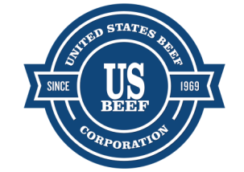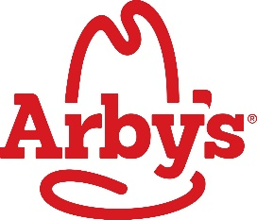

ARBY’S IN LAKEWOOD SET TO CELEBRATE GRAND RE-OPENING
New “Inspire” Design reopens on August 10

LAKEWOOD, COLORADO (August 3, 2017) – United States Beef Corporation, Inc. (US Beef), Arby’s largest franchisee, headquartered in Tulsa, Oklahoma, is excited to announce the Grand Reopening its Lakewood Arby’s at the corner of Wadsworth Boulevard and West Jewell Avenue on Thursday, August 10th.

After being closed since July 17 for the extensive remodel, Arby’s new, redesigned restaurant will occupy 3,343 square feet, with comfortable, full service seating for 70 guests, and a convenient drive thru for guests on the go, employing approximately 40 full and part-time workers.

From 10:00 a.m. to 1:00 p.m., guests will be able to spin the Arby’s prize wheel to win free food and other Arby’s branded prizes, and KBPI 106.7 FM will be broadcasting live and giving away FREE station swag. And Miles, the Denver Broncos mascot will be on site between noon and 1:00 p.m. to greet guests.

US Beef CEO, John Davis, was excited about bringing the new Arby’s “Inspire” look to Lakewood, saying “The new Arby’s “Inspire” design is a game changer. We’ve never been a competitor to burger joints. We’re unique in fast food. We’re sandwich makers, meatcrafters™, and we want our guests to have high expectations for their dining experience from the moment they drive onto our lot.”

The reason for the remodel was easy, Davis said, “This Lakewood location originally opened in 1977, over 40 years ago. Even though it had been refreshed over the years, it was time to bring it into the 21st century. Remodeling this restaurant gave us the opportunity to undergo an extensive reinvigoration process, reflecting major elements of the new “Inspire” look and direction of the brand. The revitalized restaurant includes updates to the interior and exterior, such as a fresh new color palate, strong geometric shapes and renewed materials and subway tiling. It’s our goal to be a genuine meatcrafter™ for our guests, and this newly remodeled restaurant will reflect that experience.”

Aside from focusing on form, function, and guest comfort, Arby’s new restaurant will also feature state of the art Energy Star compliant food service equipment, with extensive LED lighting technology.

For employment opportunities, go to www.work4arbys.com for more information.

About United States Beef Corporation
United States Beef Corporation, dba Arby’s, headquartered in Tulsa, Oklahoma, is the largest franchisee of Atlanta-based Arby’s Restaurant Group, Inc., now operating more than 350 restaurants serving Arby’s famous slow roasted beef sandwiches and unique menu items to hungry guests throughout the Midwest and Western United States. It is a family-owned and operated business that opened its first Arby’s restaurant in 1969, and has now grown to over 7,500 employees. US Beef also owns six Taco Bueno restaurants in Northwest Arkansas. To learn more about United States Beef Corporation, visit www.usbeefcorp.com.

About Arby’s®
Arby’s, founded in 1964, is the first nationally franchised sandwich restaurant brand, with more than 3,300 restaurants worldwide. The Arby’s brand purpose is “Inspiring Smiles Through Delicious Experiences.®” Arby’s restaurants feature Fast Crafted® service, a unique blend of quick-serve speed and value combined with the quality and made-for-you care of fast casual. Arby’s Restaurant Group, Inc. is the parent company of the franchisor of the Arby’s brand and is headquartered in Atlanta, Ga. Visit Arbys.com for more information.

With the current growth and momentum of the brand, Arby’s is actively seeking new franchisees. To learn more about available markets and requirements, visit ArbysFranchising.com.

Media Contact:
Fred Fleischner
Vice President, Corporate Communications
United States Beef Corporation, Inc. dba Arby’s
918.610.2273 (o)
918.645.0511 (m)

