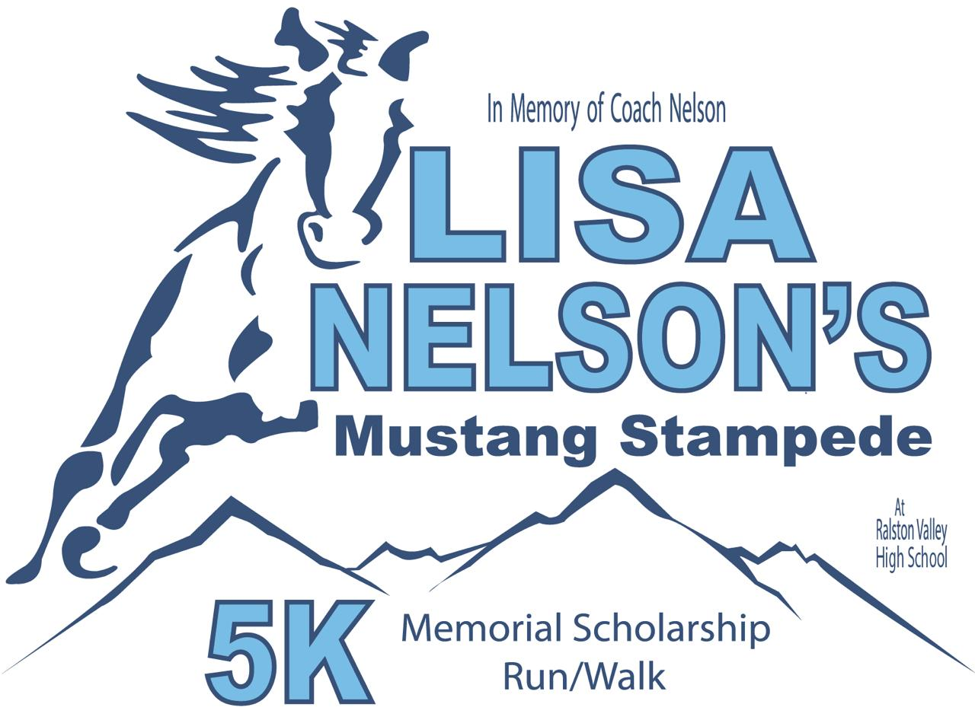
Media Contact:
Kristi M. James
(303) 941-2387
e-mail : kmj0204@aol.com FOR IMMEDIATE RELEASE

Lisa Nelson’s Mustang Stampede 5K Memorial Scholarship Run/Walk

Arvada, CO (September 10, 2017) – Ralston Valley High School will again host Lisa Nelson’s Mustang Stampede 5K Memorial Scholarship Run/Walk on Saturday, September 30, 2017 with a shotgun start at 9 AM. This event will be held at Ralston Valley High School, 13355 West 80th Avenue Arvada, CO 80005. The 5K will offer a beautiful scenic route starting and ending at the high school and conclude with a pancake breakfast. There will also be a Family Fun Run (1K).
All proceeds from the 5K will benefit the Lisa Nelson Memorial Scholarship. The Lisa Nelson Memorial Scholarship was established to commemorate the life of Coach Lisa Nelson, a beloved faculty member of Ralston Valley High School. Lisa passed away from cervical cancer in March 2013.
The purpose of this 5K Run/Walk is to unify the local community in commemoration of her life and raise funds for a college scholarship in her name that is specifically targeted to student athletes. Each year a Ralston Valley High School male and female student athlete is awarded a college scholarship in her memory.
"Lisa began her career with the Jefferson County Public School District in September 1993 as a bus driver who was finishing her teaching degree at Metro State University,” said Paul Nelson, her husband. “Throughout her career as an educator and a coach at Pomona High School, Alameda High School, Moore Middle School, and Ralston Valley High School, Lisa made a tremendous difference in the lives of her students. After her passing in March 2013, we established the Lisa Nelson Memorial Scholarship to ensure that her legacy of impacting the lives of kids continued in the form of college scholarships. Please join us Saturday, September 30th for the annual Lisa Nelson’s Mustang Stampede 5K Memorial Run/Walk and assist us in making a difference in the lives of Ralston Valley student athletes."
Jon Gillespie, Ralston Valley Student Body President, who helped organize the 2nd annual Lisa Nelson Memorial Scholarship 5K stated, "Integrity is not only important to individuals but to communities. To build integrity in a community you need strong examples. This is why we honor Lisa Nelson. I believe this tradition will live on, honoring Lisa Nelson, making a difference to her family, impacting the community, and providing scholarships to RV athletes for years to come."
The 5K has received USATF (USA Track & Field) Certification - # CO14031DCR and is also USATF Sanctioned #17-32-085. To review the certified route, obtain a GPX file for use with your GPS unit, or photos of split locations visit: http://racemeasure.com/Races/RalstonValley.
The race will be officially timed by Timing Consortium. Medals will be awarded to both male and female overall and age group winners.
Online registration is available until September 27. Early-bird registration is $20 for adults and $10 for under 18. Register here: http://bit.ly/2vIdRz3
You can also register onsite the morning of the Race at 8 AM for $30 and $15 for students.
For more information about the Lisa Nelson Memorial Scholarship, please visit: www.lisanelsonmemorialscholarship.org
####

