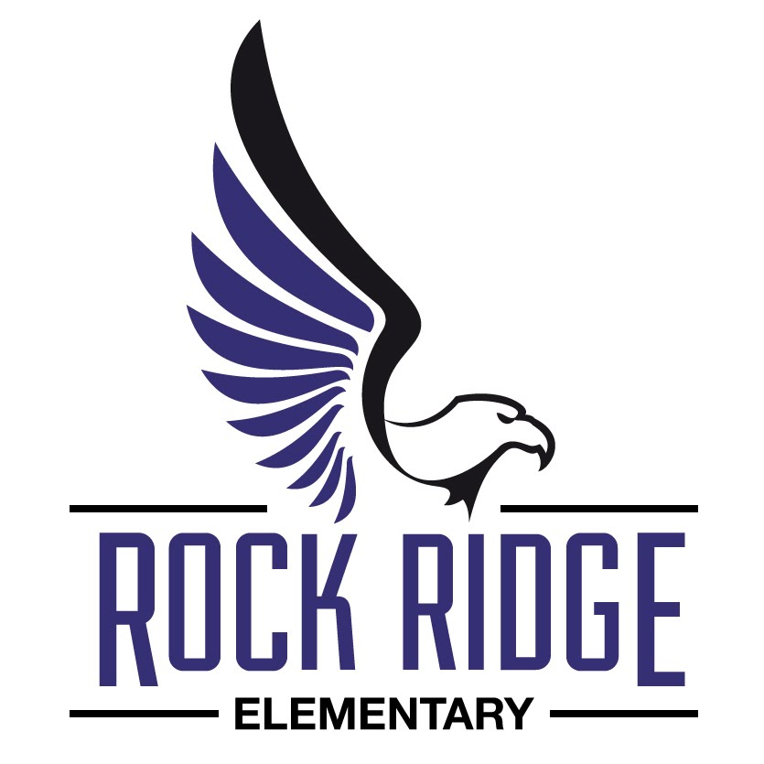

Open Enrollment
First Round
Begins November 1st ,2017
Come see what RRE is about!!!
Call: 303-387-5157 for Info.

