For immediate release:

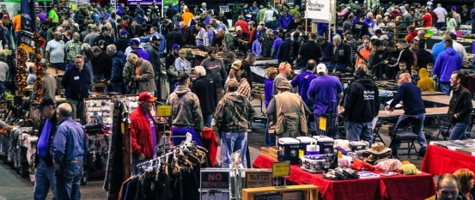
Colorado Springs Gun & Knife Show

Kicks off at Event Center

Looking to prepare for this year’s hunting season, add to your collection, or be proactive in meeting your safety needs? Come out to the Colorado Springs Gun & Knife Show to shop hundreds of tables full of guns, ammo and knives on August 12th-13th at the Colorado Springs Event Center, 3960 Palmer Park at Academy. There will be guns, knives, ammo, archery, gun parts, reloading supplies, holsters, and other related products, some at discounted prices!
This event brings together gun enthusiasts and people looking for protection. Public interest in gun ownership is still on the rise. For those looking to be well-armed, the Colorado Springs Gun & Knife Show is your one-stop shop for self-defense products & home protection with special items focused on women’s self-defense as well.
The public is invited to bring their guns and trade with the dealers for the gun they have always wanted. If you are thinking of upgrading, you will find a huge selection at great prices. For individuals interested in selling or swapping a gun, Security Personnel will be at the entrance inspecting those weapons as they enter the building.
Show promoters advocate high ethical standards of firearms trading which promotes positive public perceptions of gun and knife shows and proudly support the National Rifle Association (NRA) in their efforts to keep our right to bear arms.

Show dates, times, & ticket prices are:

Saturday, August 12th – 9am to 5pm

Sunday, August 13th – 9am to 4pm

Adults $10, Youth 16 & under free!
Active Duty Military Admission (With ID) and Seniors $9

For more information: contact Reagan Ham at (816) 396-9246 or e-mail reaganb@rjpromotions.com

