For immediate release:

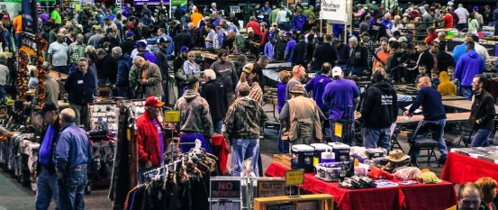
Colorado Springs
Gun & Knife Show

Shop hundreds of tables full of guns, ammo and knives at the Colorado Springs Gun & Knife Show at the Colorado Springs Event Center, 3960 Palmer Park Blvd Colorado Springs, May 20th – 21st. There will be tables full of new & used guns and ammo, archery and knives, gun parts and reloading supplies, women’s self-defense items and training, as well as holsters & other related products, some at discounted prices!
This event brings together gun enthusiasts and people looking for protection. Public interest in gun ownership is still on the rise. For men and women looking to be well-armed, the Colorado Springs Gun & Knife Show is your one-stop shop for self-defense products & home protection as well.
The Colorado Springs Gun Show invites you to bring your guns to trade with the dealers for something that you’ve always wanted. For people interested in selling or swapping a gun, Security Personnel will be at the entrance inspecting weapons as they enter the building.

Show promoters advocate high ethical standards of firearms trading which promotes positive public perceptions of gun & knife shows, & proudly support the National Rifle Association (NRA) in their efforts to keep our right to bear arms.

Show dates, times, & ticket prices are:

Saturday, May 20th – 9am to 5pm
Sunday, May 21st – 9am to 4pm

Adults: $10, Active Duty Military Admission (With ID) and Seniors: $9, Youth 16 & under: Free!

Download a discount coupon at: www.coloradospringsgunshow.com

For more info contact: Reagan Ham at 816-396-9246 or 816-646-1251 or email reaganb@rjpromotions.com

