Local Englewood Ophthalmologist, Erik Anderson MD, Helps Treat Blindness from Cataracts in Honduras
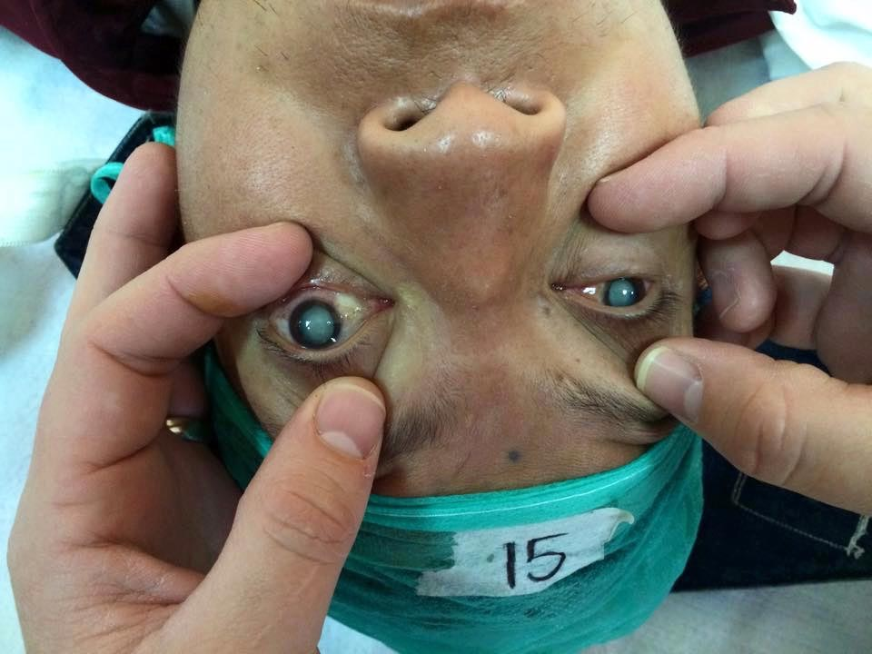
Picture:
Alt. Text: Bilateral Cataracts Causing Blindness

Dr. Anderson and his team are proud to say that 200 more Hondurans can now see again. Erik Anderson MD, an Englewood Based Ophthalmologist, recently completed a Cataract and Corneal Surgery Mission trip to San Pedro Sula, Honduras where he focused on treating cataract blindness and disability.
Dr. Anderson was struck by the sheer volume of blind cataract patients in Honduras. According to a recent World Health Organization (WHO) report, vision loss from cataracts is responsible for 51% of global blindness. Honduras is no exception and Dr. Anderson found a considerable backlog of patients given there are 160,000 Hondurans blind from the condition.

Treating Cataracts

A cataract is a clouding of the natural lens which sits behind the iris. Although cataracts are easily removed surgically, multiple barriers exist in Honduras including a lack of cataract surgeons and surgical supplies.
During the week-long trip, Dr. Anderson and a team of other eye surgeons performed 190 cataract surgeries and ten corneal transplants. “It was an honor to be part of this life-saving mission and seeing the efficiency and choreography with which our team performed low cost, 5-minute small incision cataract surgery was awe-inspiring.” Dr. Anderson remarked about the experience.
Picture:
https://erikandersonmd.com/wp-content/uploads/2017/10/dr.-anderson-honduras-cataract-surgery-e1508334895758.jpg
Alt. Text: Dr. Anderson Performing Cataract Surgery
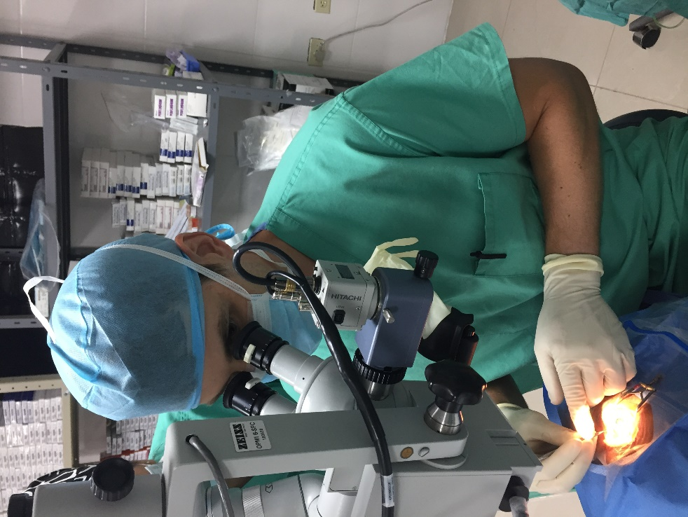

The ECHO Foundation
Dr. Anderson traveled with the Eradicating Cataracts Honduras Outreach Foundation (ECHO). ECHO was created in 2008 and started working with the Lions Eye Hospital Fraternidad in San Pedro Sula in 2013. Currently, ECHO sponsors 4-5 cataract surgery mission trips per year.
These missions have resulted in a dramatic increase in the availability of cataract surgery to Hondurans. From 2008 to 2017, the Lions Eye Hospital has increased the number of eye surgeries performed from 500 to over 1500 annually.
With donations and support from Lions Club International, Hospital Fraternidad has undergone several building renovations and equipment upgrades. Recently a third operating room was opened with modern surgical microscopes and three beds which allows three eye surgeries to be performed simultaneously. This year the hospital received another important upgrade: backup power generators.
Electricity outages are frequent in Honduras, but this year operations continued safely even when the power was out. “Performing eye surgery in the dark was one of the more difficult aspects of the trip,” Dr. Anderson said, “but the team and the generators functioned perfectly and ensured a safe surgery.”

Bringing the Experience Back Home
Picture:

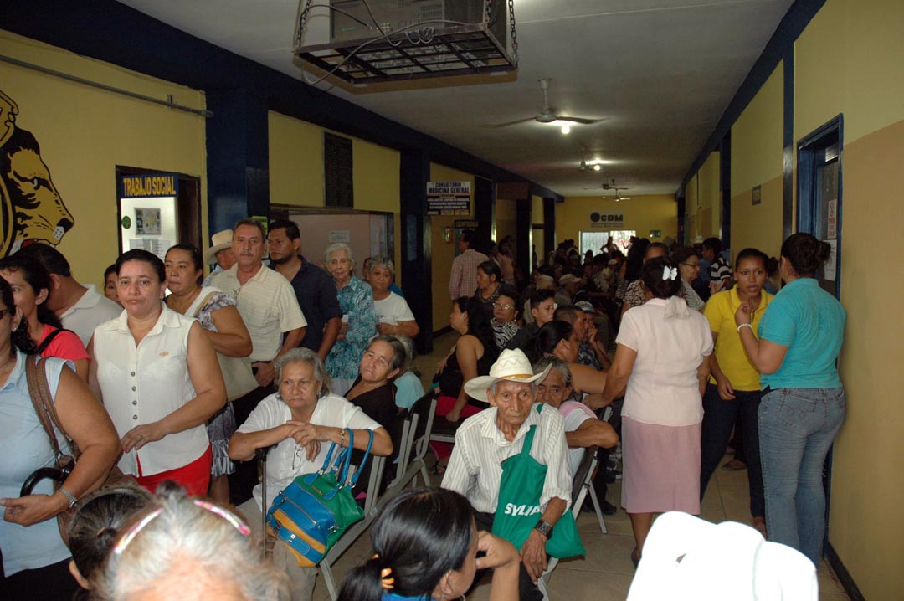
Alt. Text: Patients in the waiting room
“As the world’s population ages, cataract blindness will continue to increase,” Dr. Anderson said, “but there are cost-effective solutions to treating the disease.” Both locally and abroad, Dr. Anderson is dedicated to not only treat cataracts, but any conditions that threaten our eye health. For your best health, doctors recommend an eye exam once a year as well as visiting the doctor immediately if you suffer any vision loss.
Donations to the echo foundation are greatly appreciated and used to buy supplies and equipment upgrades. You can donate here to Operation ECHO and for more information on cataract surgery, visit Dr. Anderson’s website which has everything you need to know about the condition.
Dr. Anderson’s clinic is located next to Swedish Hospital at 601 E Hampden Ave #490 Englewood, CO 80113. Dr. Anderson offers a full range of medical and surgical eye care services including cataract surgery and general ophthalmology.

