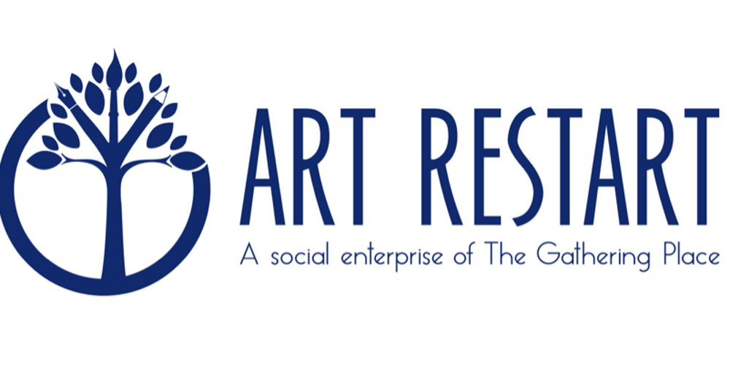
FOR IMMEDIATE RELEASE

CREATE HOPE THIS HOLIDAY SEASON FOR WOMEN IN POVERTY OR HOMELESS
2017 ART RESTART HOLIDAY CARDS NOW AVAILABLE
Artwork by women in poverty provides amazing images for holiday greetings

DENVER, CO, Sep. 20 – Remember the era when personal notes were the way to connect and stay connected with others? Receiving a letter or greeting card by real mail was like having a personal conversation with someone — an authentic connection that created a visual in the mind and a sparkle in the eye.
While it may seem a little early to be thinking about the 2017 holiday season, Art Restart’s 2017 holiday card collection and Look Book are now available at http://www.artrestart.org so you can plan how you will convey a celebration of happiness with loved ones throughout the holidays. Art Restart has the perfect holiday cards to make family, friends, business associates, customers, and all those near-and-dear feel special. With an Art Restart card you can express holiday wishes with a purpose -- helping women who are experiencing poverty. In the process, Art Restart creates a means for you to stay emotionally connected to your world.

“No time of year inspires the sentiments of love, caring and generosity quite like the holiday season,” said Teresa Densmore, Director of Art Restart. “This year, we’ve truly topped ourselves with the most unique assortment of greeting cards featuring original art, created by members of The Gathering Place. There’s a card for every person on your list.”

Art Restart is a social enterprise of The Gathering Place, Denver’s only daytime drop-in center for women, their children, and transgender individuals who are seeking programming and necessary services to help them become self-sufficient. For nearly 30 years, it has been a place of hope where positive relationships and essential resources transform lives every day. Art Restart began as a social enterprise in 2013 to allow The Gathering Place provide the women it serves with opportunities to earn money, to stimulate attitude change in the community about homelessness, and to establish mission-supporting income from large quantity greeting card sales.

Densmore says, “The Art Restart program provides opportunities for women who are experiencing poverty to transform their lives through art. As Art Restart artists, they receive royalties when companies or individuals select their art while the rest of the proceeds from each sale go back to The Gathering Place to assist with the furthering of programs and services. You literally can do good without much effort.”

Companies like Vectra Bank are using Art Restart cards as a demonstration of their commitment to corporate social responsibility. “Not only do Art Restart cards meet communication needs for their business and individual customers, but it’s also an easy way to help others,” says Densmore.

Bruce Alexander, president and CEO of Vectra Bank says, “When The Gathering Place launched Art Restart as its social enterprise, we just knew Vectra had to be a part of this endeavor… We’re so proud to have been Art Restart’s first client, and thrilled to be able to share their story and our warm holiday wishes with our clients and prospects through their cards each year.”

Connie M. Proulx, Executive Director of Wheeler, Trigg, O’Donnell LLP, says, “Art Restart has been a wonderful resource for holiday cards for our law firm. Because they are not the typical mass produced corporate cards, Art Restart gives us an opportunity to share our less formal, but still professional side with our clients during the holiday season, while at the same time show our firm’s support of The Gathering Place.”

The 2017 Holiday Collection features original art that portrays beautiful scenes of holiday and winter. Most notable are Gold Trees by EHS, Holiday Homes by BJA, and Snow Storm by VEC. “The initials of the artists are used here because of the need to respect the privacy of our members, some who are victims of domestic violence,” said Densmore. “And there is no reason companies cannot get the jump on 2017 holidays by ordering cards from this collection now,” she added. “It sends a powerful message to an organization’s audience about who they are. If we know anything about consumers and commercial customers today, it is this: when given a choice between virtually equal service and product options, most will choose the one that links to a social mission,” she continued.

To learn more about the 2017 Art Restart collection, visit the website at www.artrestart.org or contact Teresa at Teresa@tgpdenver.org or 303-996-9034.

About Art Restart
Art Restart was conceived to develop new revenue streams to support the vitally needed services The Gathering Place provides and is built on four principles. 1) Radical Acceptance: our artists are individuals deserving of dignity, recognized for their strengths, valued for their unique characteristics and respected for their creativity; 2) Transformation: we provide women a means to achieve self-sufficiency, earn money, rediscover their independence and believe that they can transform their lives; 3) Affirmation: our women are truly artists. Through artistic self-expression they feel validated when their work sells, creating a ripple effect of confidence that positively affects their lives. 4) Sustainability: provide additional funding to The Gathering Place, ensuring it can continue to serve members in meaningful ways.
###

About The Gathering Place
The Gathering Place (TGP) created Art Restart as a social enterprise to provide its members with opportunities to earn money and to build earned revenues. For 30 years, TGP has offered essential resources and personal growth programs to women, children, and transgender individuals during the day.

FOR INFORMATION
Deborah Radman
Deborah.radman@rad-comm.net
917-841-9228

