FOR IMMEDIATE RELEASE

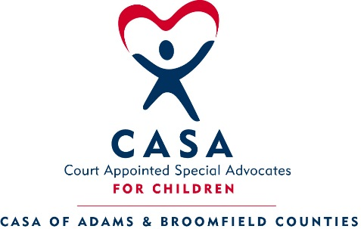
For additional information contact: Emma Townsend
Donor Relations Coordinator
Office # 303.835.5542
emma@casa17th.com

August 21, 2017

ENVISION a bright future for every child at CASA’s FREE Light of Hope event

Adams & Broomfield Counties, CO-CASA (Court Appointed Special Advocates) of Adams & Broomfield Counties will be hosting its annual Light of Hope event on Thursday, October 19th, 2017 at Stonebrook Manor (650 East 124th Avenue, Thornton, CO 80241). There will be both a breakfast from 8:00 – 9:00am as well as a luncheon from 12:00 – 1:00pm. Guests can choose to attend either program. There is no fee to attend; however, guests will be encouraged to make a financial contribution to support CASA and its mission.

Funds raised from the event will help fund CASA’s mission to provide specially selected and trained community volunteers, CASAs, to advocate for abused and neglected children in the pursuit of safe and permanent homes. CASA is a volunteer-based, nonprofit organization that trains , recruits, and supervises community volunteers to represent the best interests of our most vulnerable citizens-child victims of physical, sexual or emotional abuse and neglect. CASA Volunteer Advocates are appointed by judges to be a voice for these children in court. The desired result is that children are placed into safe, loving homes where they can thrive.

Throughout the event, CASA will share with guests the impact the program is having in the community including a mission moment highlighting former CASA Youth and their CASA Volunteer Advocates.

CASA of Adams & Broomfield Counties currently serves more than 500 of the abused and neglected children in need of a caring CASA Volunteer Advocate. Join CASA at this year’s Light of Hope to help create a brighter future for every child.

To RSVP for the breakfast or luncheon or to make a financial contribution, please contact Emma Townsend at emma@casa17th.com or at 303.835.5542. You can also visit casa17th.org to learn more.

Light of Hope would not be possible with the generous support from the following sponsors: Envision Sponsors: Forest City Stapleton, Inc., Conoco Phillips

CASA (Court Appointed Special Advocates) of Adams and Broomfield Counties is a 501 (c)(3) non-profit organization that works to make sure that every child who cannot live safely at home has a caring, compassionate CASA Volunteer Advocate who will help fight for their right to be safe, ensure that they are treated with dignity, and assure their safe passage out of foster care, building a stronger community for all. Each year, in Adams and Broomfield Counties, there are over 1,100 children who have been physically, sexually, or emotionally abused or neglected, and who are in desperate need of a caring, committed CASA Volunteer Advocate to speak up for their best interests. In Adams and Broomfield Counties, there are over 200 CASA Volunteer Advocates, but we are in need of more great community members to become advocates for children. CASA conducts volunteer training classes six times a year. For more information about CASA, call 303.835.5530 or visit www.casa17th.org.

#######

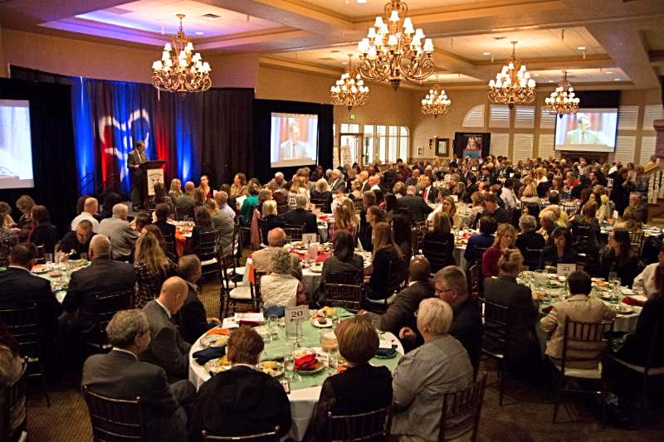
Last year’s Light of Hope fundraising luncheon.

