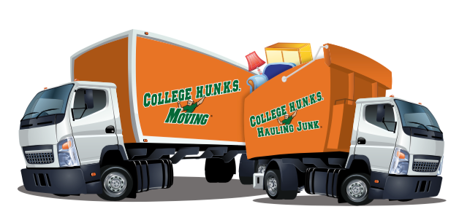
Denver North
College Hunks Hauling Junk
1700 Broadway Unit 1-O Denver, CO 80221
Mike.Slater@CHHJ.com
303-525-4423

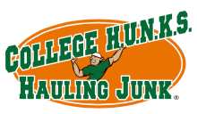
7/5/2017

News Partners,

On 6/28 our team of 6 HUNKS moved the Senior Hub offices from Federal Heights by Waterworld to the Arapahoe House just south of North Suburban. They did it all in one day!

We are always happy to assist the community where we can! Everyone was happy to have us and our professional approach. We are H.U.N.K.S. We give Honest, Uniformed, Nice, Knowledgeable, Service.

I am the owner and I am building leaders in a fun, enthusiastic team environment.

Thanks,

Mike Slater
303-525-4423

