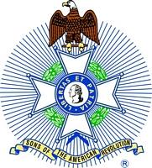
For Immediate Release:

Robert W. Haines
President, Mount Evans Chapter
Colorado State Society
Sons of the American Revolution
303-526-3051
rwhdjh@aol.com

Four Dahms Join Mt. Evans Chapter of the Sons of the American Revolution

Denver, CO, January 13, 2018 – The Mt. Evans Chapter of the Colorado Society of the Sons of the American Revolution (COSSAR) inducted Scott Dahm and his three sons: Noah, Andrew and Samuel, as well as Edward “Ted” Seidler and Gary Frazier into the Sons of the American Revolution at the Chapter’s Annual Meeting.

On Saturday, January 13, 2018 at the Annual Meeting of the Mt. Evans Chapter of the Colorado Society of the Sons of the American Revolution (SAR) held at the Park Hill Golf Club, Scott Dahm and his three sons: Andrew, Noah and Samuel, were inducted into the SAR. Also inducted into the Mt. Evans Chapter was Edward “Ted” Seidler and Gary Frasier.

“We are always looking forward to new members joining the Sons of the American Revolution,’ explained Rick Neeley, Registrar for the Mt. Evans Chapter. The Registrar is responsible for helping prospective members complete the necessary documentation for membership and sponsoring their applications through the State and National process. “We are especially pleased when these new members include young people who can join either as Regular Members or as Junior Members until the age of 18,” further explained Rick Neeley.

“It is gratifying to see new members who have completed the work of documenting the service of an ancestor either in the colonial military or who otherwise supported the American Revolution,” described Captain Bob Easterly (U.S.N.R., Ret.), the President of the Mt. Evans Chapter. “We welcome them into the Chapter and look forward to them participating in our future meetings.”

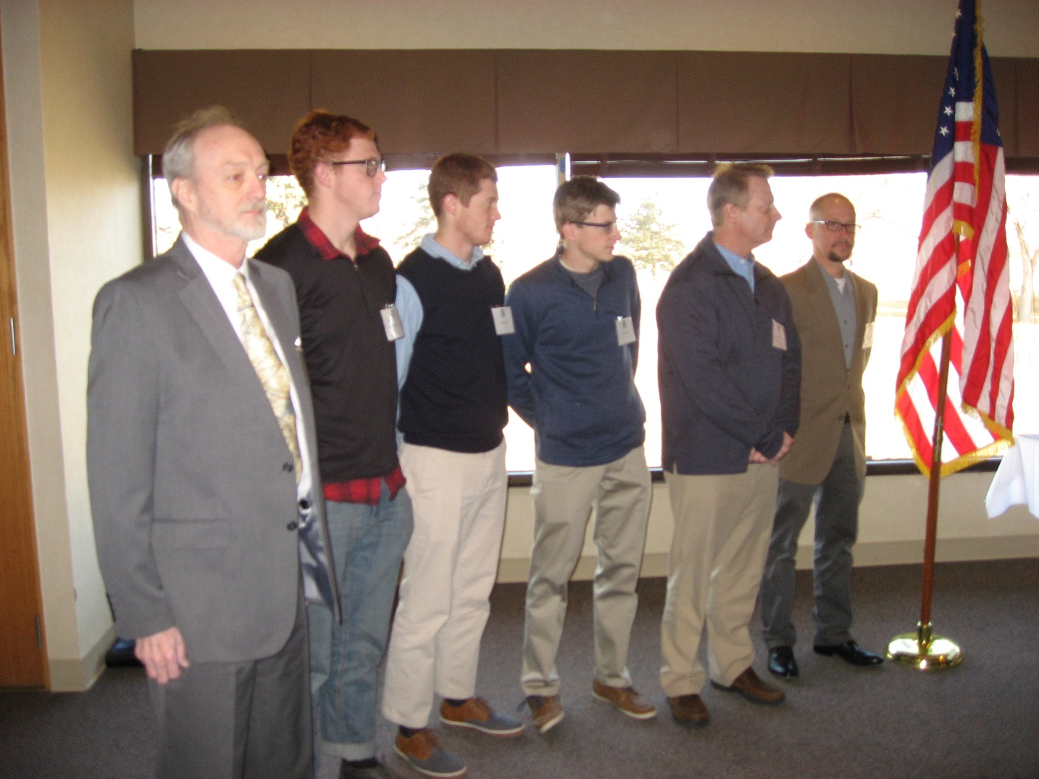
Left to Right: Edward “Ted” Seidler; Noah Dahm; Andrew Dahm; Samuel Dahm; Scott Dahm; and Gary Frazier.

The Mt. Evans Chapter holds five meetings a year: An Annual Meeting and four quarterly meetings. These are usually breakfast meetings held around the Denver Metro Area with presentations on topics related to history and the activities of the Sons of the American Revolution. The most recent Annual Meeting, held on January 13, 2018 at the Park Hill Golf Club, featured a speech by the Honorable Peter A. Weir, the District Attorney for the First Judicial District, which includes Gilpin and Jefferson Counties.

The Mt. Evans Chapter represents those members of the Sons of the American Revolution living in the Denver Metro area. It is one of four Chapters in the Colorado Society. The Sons of the American Revolution (SAR), the largest male lineage organization in the U.S., consists of 50 societies with more than 500 local chapters, several international societies and over 34,000 members. SAR is dedicated to assisting our members, schools, teachers and the general public in their efforts to sustain and preserve our history and constitutional principles.

