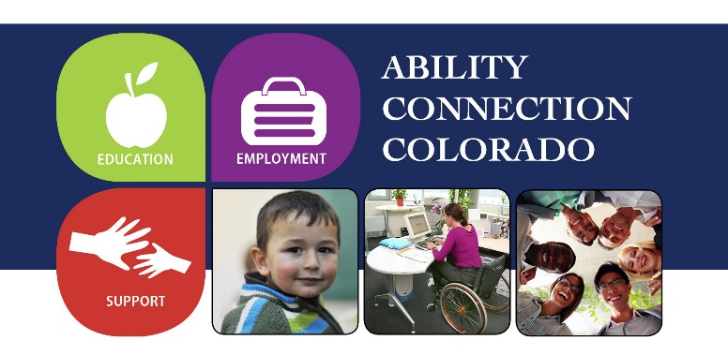
For Immediate Release

September 6, 2017

For further information, contact:

Terri Armstrong, Development Director

Direct 303-226-5520
Office 303-691-9339
Cell 303-941-4553
tarmstrong@abilityconnectioncolorado.org

William Hill Estate Winery named wine maker 2017 for the 34th annual wine in the pines

Denver, CO- (September 6, 2017) Founders Mike and Margaret Smith today announced that William Hill Estate Winery will host the acclaimed Winemaker’s Dinner at the 34th Annual Wine in the Pines. Held annually at the renowned Ranch in Keystone Colorado, a AAA Four Diamond™ restaurant, Wine Spectator DiRoNa winner, and recognized Best Restaurant in Colorado by the prestigious Zagat Survey®. Genius Head Chef Vincent D’Amato will demonstrate an exquisite balance of flavours and textures paired with exquisite William Hill Estate wines. This Two Thousand Seventeen spectacular five course dining experience will characterize the evening phenomenon, in recognition of thirty-four remarkable years.

About William Hill Estate Winery: Founded in 1976 by visionary vineyard developer William Hill, they are located on an exceptionally unique 200-acre parcel at the foot of Atlas Peak on the Silverado Bench. With nearly 40 years of experience growing wine there, they have used their expertise, knowledge and instinct to deliver extraordinary fruit that showcases the distinctive characteristics of their site. Each variety, each wine and each tier has been skillfully crafted to meet their high standards. This disciplined approach to producing excellent wine is apparent in every glass of William Hill Estate they pour today.

About Wine in the Pines: This benefit for Ability Connection Colorado’s Kelly Smith Employment Center has justifiably earned the reputation of a premier wine and culinary event. As with fine wine, age and dedication have become the evolutionary ingredients that have turned Wine in the Pines into one of the most elegant, enchanting and exciting events anywhere. Inspired by Kelly Smith, the daughter of founders Mike and Margaret Smith, owners of Dillon Ridge Liquors, Wine in the Pines is a fundraiser held each of the last 34 years to help support the Kelly Smith Employment Center at Ability Connection Colorado. Ability Connection Colorado is a non-profit organization which serves over 40,000 Colorado children, adults and families through early childhood education, employment and statewide support services. Join us as we celebrate our 34th year! Indulge in some of Colorado's most savory cuisine prepared flawlessly by Keystone's foremost chefs, paired with exquisite wines from around the world. This extraordinary gathering of culinary talents, discriminating wines and unmatched entertainment and atmosphere are all assembled to celebrate this premiere epicurean event! Wine in the Pines is October 20 & 21, 2017, Keystone Resort. Tickets are available online at www.wineinthepines.org or locally starting October 1, 2017 at Dillon Ridge Liquors in Dillon, Colorado.

###

