
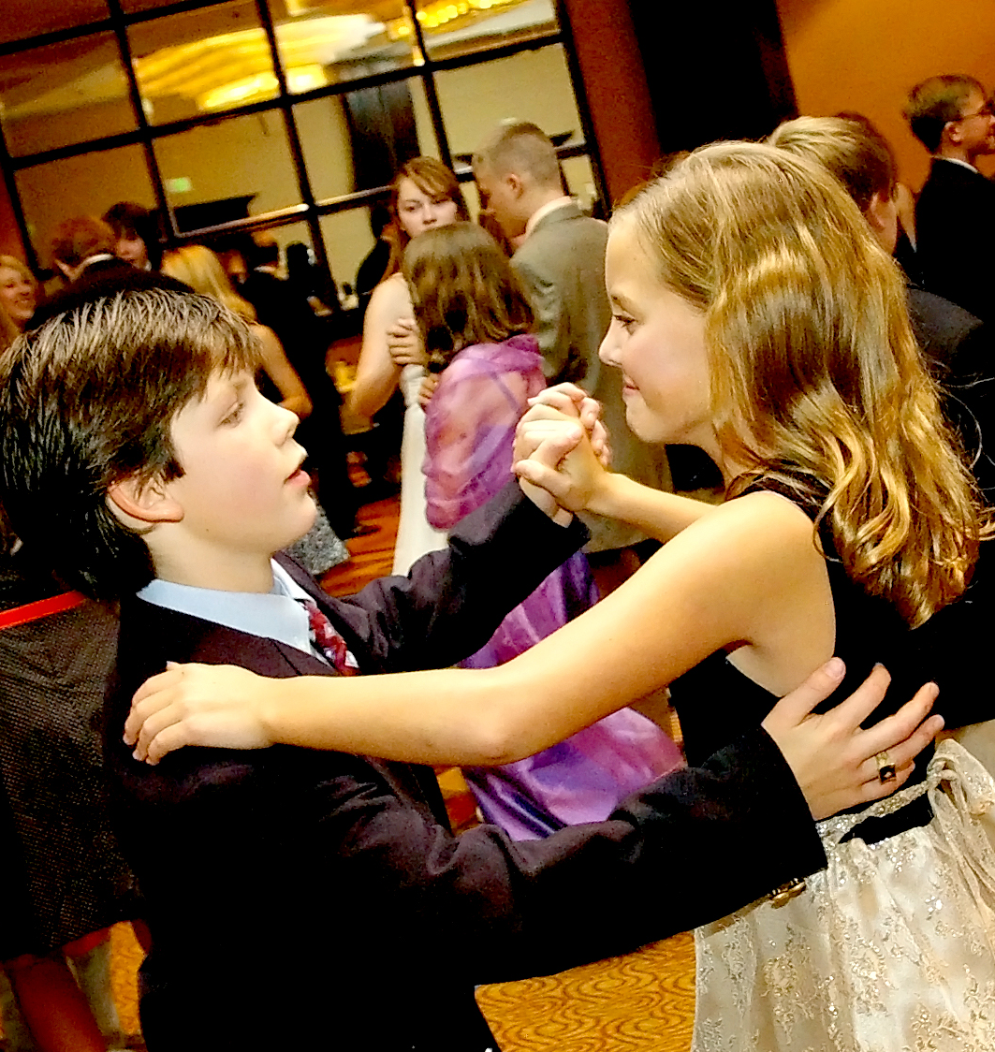
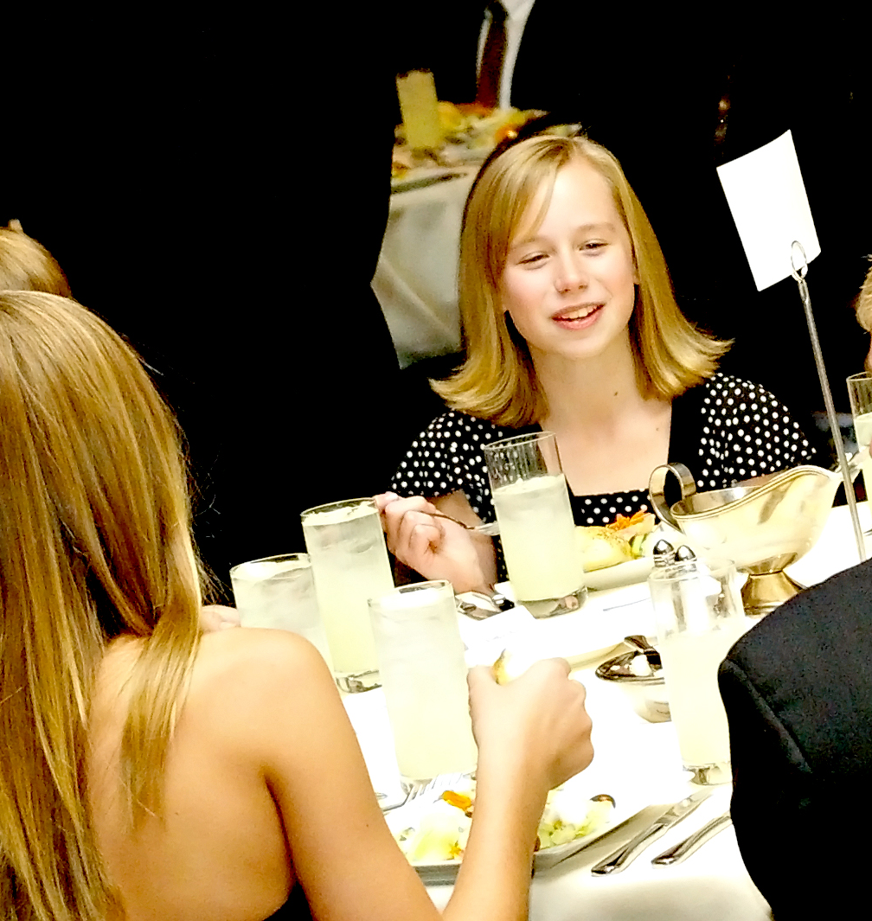


COTILLION CELEBRATES 38 YEARS IN SENSE & CIVILITY
at the Douglas Buck Community Center
(previously at Columbine Country Club and returning once renovations are complete)

What has parents buzzing in the Columbine Valley community? Perhaps it is the 38th Annual Columbine Cotillion beginning Friday, September 22nd. The Columbine Cotillion is a progressive course in social skills, dance, and etiquette education. In this fast paced culture, parents are so often preoccupied with driving their children to soccer practice, ballet lessons, and of course getting dinner on the table – it is no wonder we squirm when thinking about adding more to the array of activities. However, perhaps we are losing sight of what may be essential for our children as they prepare for their future.

According to studies conducted by Harvard University, The Carnegie Foundation and The Stanford Research Institute – over 85% of getting a job, keeping a job and getting promoted in the job is based on social skills.

The organization that directs the Columbine Cotillion, JDWC (Jon D. Williams Cotillions), is celebrating its 65th Anniversary in the art of social skills and dance education. A far cry from the charm and finishing schools once acquainted with the term “cotillion,” The Company utilizes dance as a tool to teach beneficial social skills in which the students actually have fun! The five-session, 1½ hour course provides a positive and healthy environment for students to interact, develop confidence, and acquire skills they will utilize for the rest of their lives – wherever they go, whatever they do, whomever they meet.

The results speak for themselves. Recent surveys on JDWC cotillions have demonstrated that: 96% of students believe cotillion has helped prepare them for their future, and 93% believe the program gave them more confidence in social and unfamiliar situations. Of parents, 98% believe the cotillion experience will have a positive impact on their child’s future social relationships and career, and 96% believe Cotillion has helped their child understand how social skills relate to character.

Two progressive levels of cotillion classes are being offered for 4th and 5th grades, and
6th and 7th grades. Classes begin on Friday, September 22nd.

For information & registration visit www.cotillion.com or contact Esther Bridge at columbine@cotillion.com .

